**Experiment # 01**

**OBJECTIVE:**

To become familiar with initialization, declaration and population ion of 1- D, 2-D Array

**Array Initialization:**

The process of assigning values to array elements at the time array declaration is called array initialization.The initialization process provides a list of initial values for array elements .The values are separated with commas and enclosed within braces. There must be at least one initial value between braces .A syntax error occurs if the values in braces are more then the length of array.if the number of initial value is less then the array size, the remaining array elements are initialized to zero.

**Syntax:**

Data_Type Identifier [Length]={List of values };

**Example:**

#include<iostream>

#include<conio.h>

using namespace std;

int main()

{

int marks[3]={28,29,33};

cout<<" The Values of Array are :"<<endl;

cout<<marks[0]<<","<<marks[1]<<","<<marks[2];

getch();

}

**OUTPUT:**

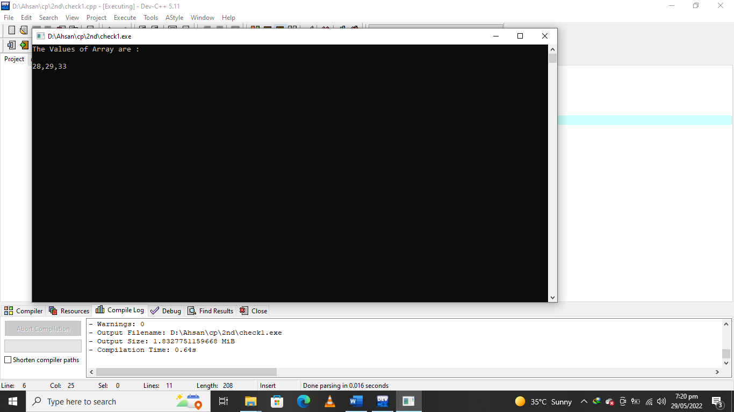

**Declaring One-Dimensional Array:**

A type of array in which all elements are arranged in the form of a list is known as One Dimensional Array.It is also called single dimensional array . it consist of one column or one row. The process of specifying array name,length and data type is called Array Declaration

**Syntax:**

Data_Type Identifier[Length];

**Example:**

Int marks[5];

**Example:**

Develop a code in C++ that initializes the three array elements.it then display all values in the array using loops.

#include<iostream>

#include<conio.h>

using namespace std;

int main()

{

int arr[3]={22,44,66},i;

cout<<" The values in array are :"<<endl;

for(i=0;i<3;i++)

cout<<arr[i]<<endl;

getch();

}

**OUTPUT:**

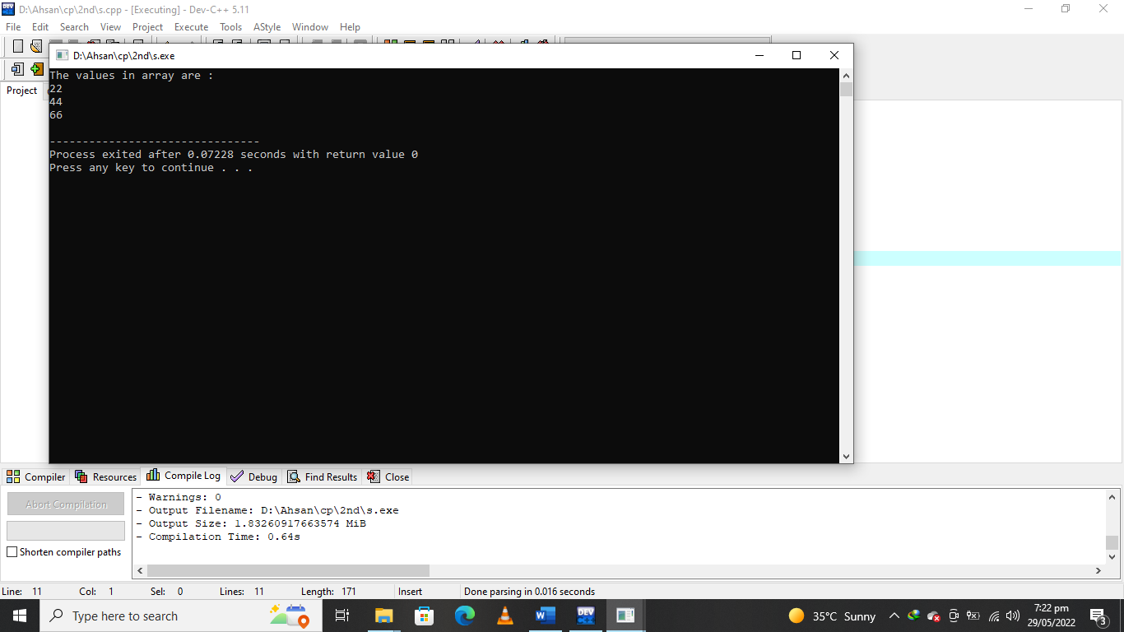

**Declaring Two-Dimensional Array:**

A two-dimensional array consists of a certain number of rows and columns:

const int NUMROWS = 3;

const int NUMCOLS = 7;

int Array[NUMROWS][NUMCOLS];

|  |  |  |  |  |  |  |  |
| --- | --- | --- | --- | --- | --- | --- | --- |
|  | 0 | 1 | 2 | 3 | 4 | 5 | 6 |
| 0 | 4 | 18 | 9 | 3 | -4 | 6 | 0 |
| 1 | 12 | 45 | 74 | 15 | 0 | 98 | 0 |
| 2 | 84 | 87 | 75 | 67 | 81 | 85 | 79 |

Array[2][5] 3rd Value in 6th column   
Array[0][4] 1st value in 5th column

The declaration must specify the number of rows and the number of columns, and both must be constants.

**Processing a 2-D Array:**

A one-dimensional array is usually processed via a for loop. Similarly, a two-dimensional array may be processed with a nested for loop:

for (int Row = 0; Row < NUMROWS; Row++) {

for (int Col = 0; Col < NUMCOLS; Col++) {

Array[Row][Col] = 0;

}

}

Each pass through the inner for loop will initialize all the elements of the current row to 0.

The outer for loop drives the inner loop to process each of the array's rows.

**Example:**

int Array1[2][3] = { {1, 2, 3} , {4, 5, 6} };

int Array2[2][3] = { 1, 2, 3, 4, 5 };

int Array3[2][3] = { {1, 2} , {4 } };

If we printed these arrays by rows, we would find the following initializations   
had taken place

for (int row = 0; row < 2; row++)

{

for (int col = 0; col < 3; col++)

{

cout << setw(3)<<Array1[row][col];

}

cout << endl;}

Rows of Array1:

1 2 3

4 5 6

Rows of Array2:

1 2 3

4 5 0

Rows of Array3:

1 2 0

4 0 0

**LAB Task:**

**Q#1** Develop a code in C++ to calculate the average of the marks of 10 students by using

array?

**Q#** **2** Develop a code in C++ to find the maximum and minimum value in array of five

elements?

**Q#3** Develop a code in C++ that will add the two matrix of the same order?

**QUESTION NUMBER : 01:**

Develop a code in C++ to calculate the average of the marks of 10 students by using

array?

**PROGRAM:**

#include <iostream>

#include<conio.h>

using namespace std;

int main()

{

cout<<" \t\t\t\t\t Marks of ten student are give in blow "<<endl;

int arr[10]={99,98,675,59,43,98,79,90,61,65},i,sum=0;

float avg=0.0;

for(i=0; i<9; i++)

{

cout<<"The Marks of student "<<i+1<<"="<<arr[i]<<endl;

sum=sum+arr[i];

}

avg=sum/10;

cout<<"\n The average of the ten student are ="<<avg;

return 0;}

**OUTPUT:**

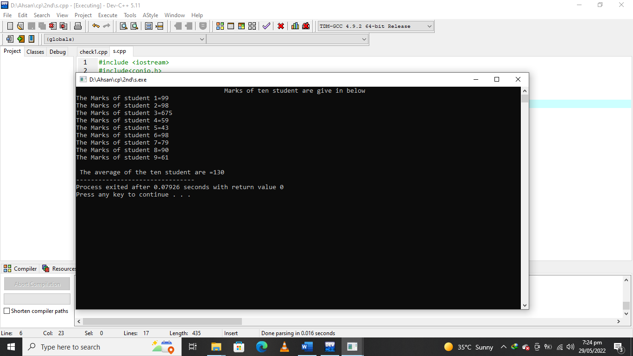

**QUESTION NUMBER : 02:**

Develop a code in C++ to find the maximum and minimum value in array of five

elements?

**PROGRAM:**

#include <iostream>

#include<conio.h>

using namespace std;

int main()

{

int a[10];

int max, min,i;

for (i=0; i<5; i++)

{

cout<<" Enter the value of the array at index ="<<i<<" = ";

cin>>a[i];

if(max<a[i])

max=a[i];

if(min>a[i])

min=a[i];

}

cout<<"\n The maximum value of the array is="<<max<<endl;

cout<<"\n The minimum value of the array is ="<<min;

}

**OUTPUT:**

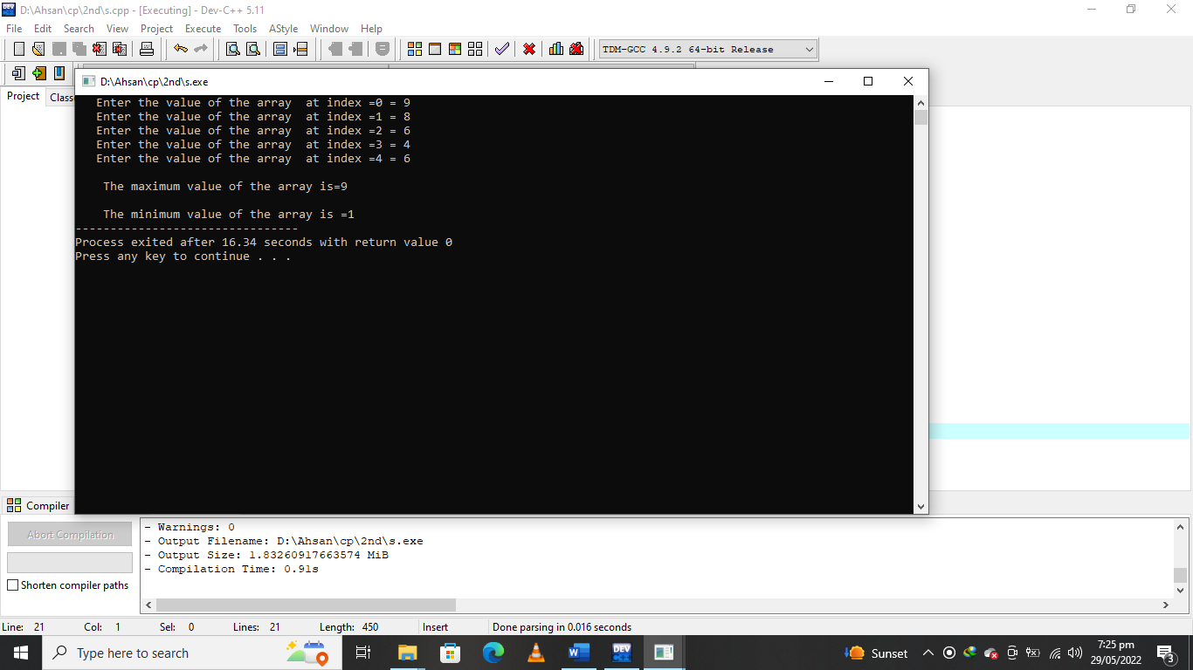

**QUESTION NUMBER : 03:**

Develop a code in C++ that will add the two matrix of the same order?

**PROGRAM:**

#include <iostream>

#include<conio.h>

using namespace std;

int main()

{

int m1[3][3], m2[3][3] ,m3[3][3];

int i,j,row,colum;

cout<<" Enter the number of rows:";

cin>>row;

cout<<" Enter the number of columns :";

cin>>colum;

cout<<"\n 1st Matrix input:\n";

for(i=0; i<row; i++)

{

for(j=0; j<colum; j++)

{

cout<<"\nMatrix 1 ["<<i<<"]["<<j<<"]=";

cin>>m1[i][j];

}

}

cout<<"\n 2st Matrix input:\n";

for(i=0; i<row; i++)

{

for(j=0; j<colum; j++)

{

cout<<"\nMatrix 2 ["<<i<<"]["<<j<<"]=";

cin>>m1[i][j];

}

}

cout<<"\n THE Addition of Matrices..\n";

for(i=0; i<row; i++)

{

for(j=0; j<colum; j++)

{

m3[i][j]=m1[i][j]+m2[i][j];

}

}

cout<<"\n The resultant Matrix is:\n";

for(i=0; i<row; i++)

{

for(j=0; j<colum; j++)

{

cout<<"\t"<<m3[i][j];

}

cout<<endl;

}

}

**OUTPUT:**

